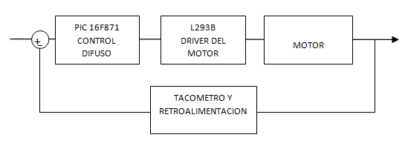



TACOMETRO Y

RETROALIMENTACION

PIC 16F871

CONTROL DIFUSO

MOTOR

L293B

DRIVER DEL MOTOR